**Death Note season 2: Release, Cast, Plot** 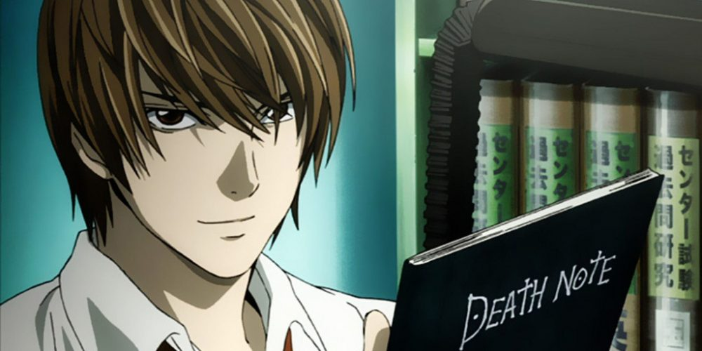

**Death Note**, a Japanese anime grounded on the *Death Note* manga series written by Tsugumi Ohba and Takeshi Obata. It was first premiered in 2006 and then it became the highest grossing anime all over the world at that time with a high imdb rating. So, you can think of the level of excitement an anime fan could have for hearing any positive news about the release of **season 2** of *Death Note*.

**Death Note Season 2: Release Date**

Almost after 14 years of the release of its first *season*, some news came about the further story to be written by the creator in January 2020. Then the manga was released in February, 2020. All these 14 years there was no news about the creation of another *season* for the **anime** because of the lack of the resources. *Season 1* used almost all the volumes of the manga and ended the series, binding up all the characters. So, fans were perplexed that whether there will be another season or not. But fortunately, the writers of the manga series came up with another manga. Since the project is huge, we can expect a lot of time to be invested in its production. So, we may be able to hear some news about the release of ***season 2*** in late 2021.

**Death Note Season 2: Cast**

We expect the cast from *season 1* to return to their roles. So, following are the probable cast members:

|  |  |  |
| --- | --- | --- |
| Characters | Japanese voice actor | English voice actor |
| **Light Yagami** | Tatsuya Fujiwara | Brad Swaile |
| L | Kenichi Matsuyama | Alessandro Juliani |
| Misa Amane | Erika Toda | Shannon Chan-Kent |
| Royuk | Shidou Nakamura | Brian Drummond |
| Rem | Shinnosuke Ikehata | Michael Dobson |
| Kiyomi Takada | Nana katase | Heather Doerksen |
| Watari | Shunji Fujimura | Ron Halder |
| Soichiro Yagami | Takeshi Kaga | Christopher Britton |
| Sayu Yagami | Hikari Mitsushima | Kristie marsden |
| Kanzo Mogi | Shin Shimizu | John Murphy |
| Sachiko Yagami | Michiko Godai | Saffron Henderson |
| Shuichi Aizawa | Tatsuhito Okuda | Trevor Devall |
| Touta Matsuda | Sota Aoyama | Vincent Tong |
| Sanami | Miyuki Komatsu | Janyse Jaud |
| Hirokazu Ukita | Ikuji Nakamura | Jeremy From |
| Ryotaro Sakajo | Masanori Fujita | Michael Donovan |

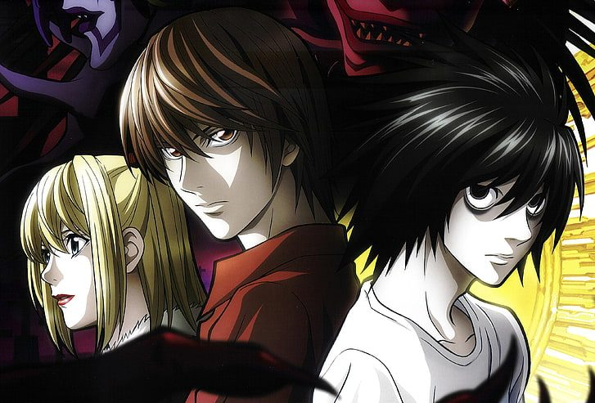

**Death Note Season 2: Plot**

When the manga was released in February 2020, the readers came to know that the new manga story has moved on from ***Light Yagami***’s story. Although fans enjoyed the newly released manga but some of them dejected the ending in the special manga and complained against the story, telling that it’s not that fascinating like the original manga series. Even if the story moved from Light *Yagami*, *Shinigami Ryuk* come back to the earthling world. He speaks to a middle-schooler *Minoru Tanaka* who’s as brilliant as *L*. But still unlike the previous protagonist, *Minoru* plans to exchange the strength of *Kiara* to the highest paying bidder. And when the auction is made public, world leaders from distinct countries, starts bidding for the death note. Yet the story goes cascading after the bidding process is done. There are few reports which suggests that **Madhouse** might accept this story as the plot for **Death Note Season 2**. But since many fans dejected this ending from the newly written manga so there are chances that the creators will come up with new conclusion for the **season 2**.